**MULTIPLE FILE COPYING**

**LAB # 07**



**Fall 2023**

**CSE-302L Systems Programming Lab**

Submitted by: **Ali Asghar**

Registration No**. : 21pwcse2059**

Class Section: **C**

“On my honor, as student of University of Engineering and Technology, I have neither given nor received unauthorized assistance on this academic work.”

Submitted to:

**Engr. Abdullah Hamid**

DATED: 28 \01 \2024

**Department of Computer Systems Engineering**

**University of Engineering and Technology, Peshawar**

**OBJECTIVES:**

* To learn about UNIX input and output.
* To learn about File Handling.

**Tasks:**

**Task 01:**

Write a program that copies two files sequentially in a single process.

Code :

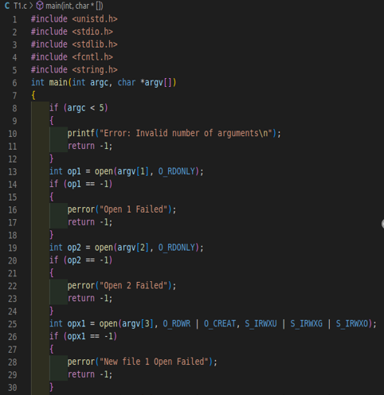

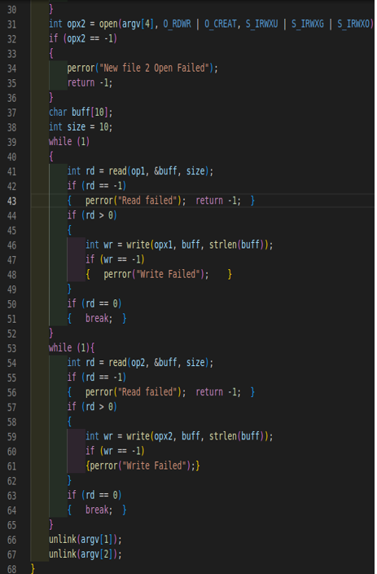

Ouput :

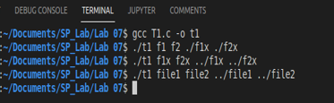

**Task 02:**

Write a program that monitors two files by forking a child .

Code :

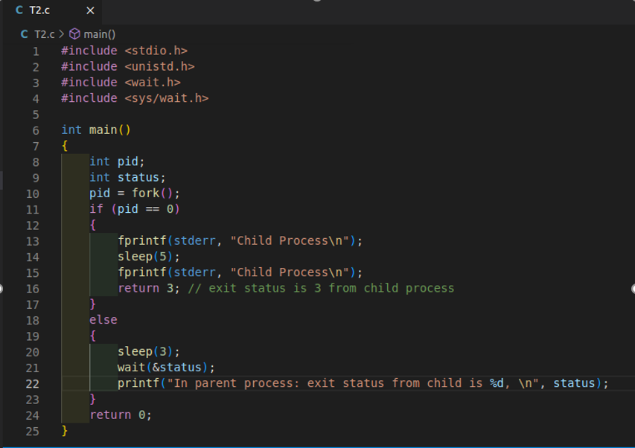

**Ouput :**

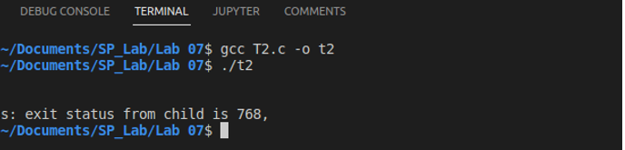

**Task 03:**

Write a program that monitors two files using 'select' .

Code :

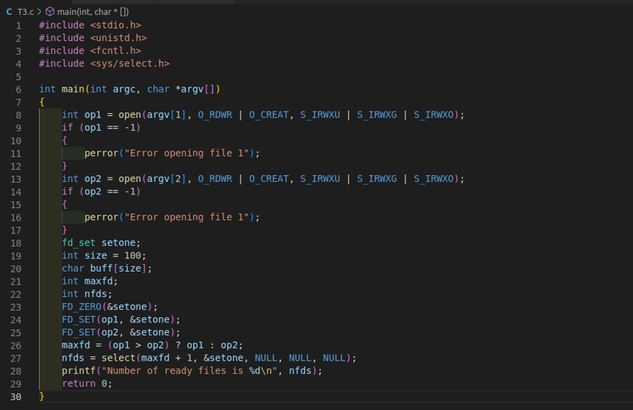

**Ouput :**

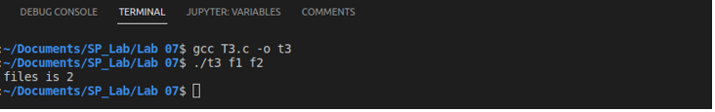

**Task 04:**

Write a program that monitors N files using 'select'.

Code :

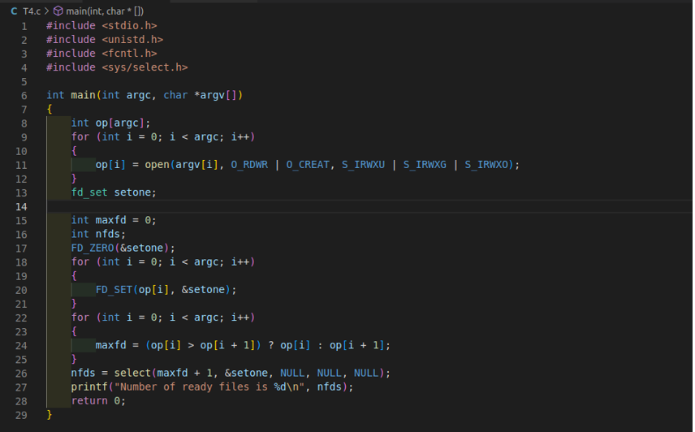

**Ouput :**

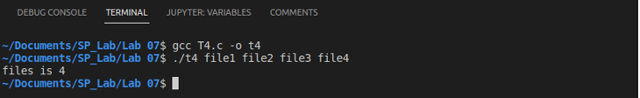

**Task 05:**

Write a function that creates a delay of N seconds using select function. Pass N as an argument to the function .

Code :

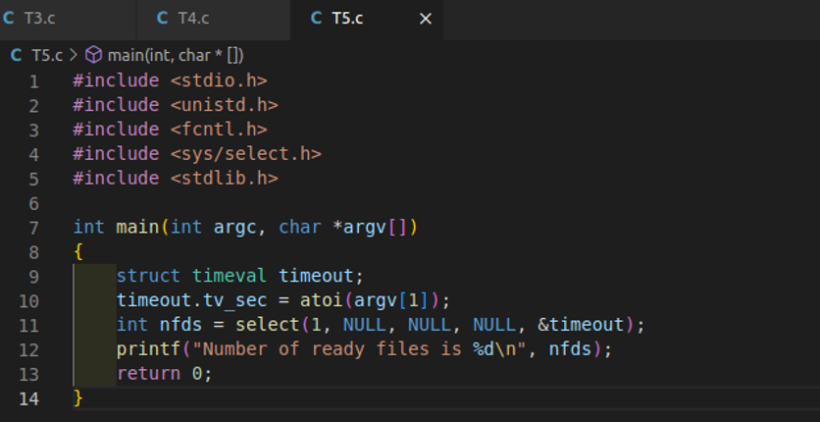

Ouput :

